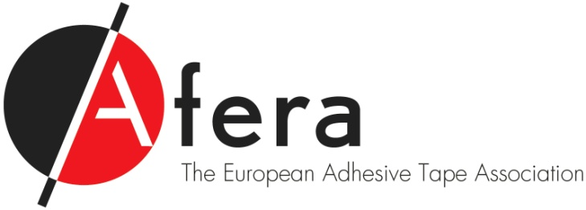

Dear [Contact person],

It was good talking with you just now. [Short personal message]

As a collective of best-in-class businesses operating within the adhesive tape market, I feel we understand your unique position in the European value chain and your significance to the markets’ end-user customers.

As we have discussed, here are the top 15 points which I think will motivate you to join Afera:

1. Discuss market opportunities and strengthening your business position in a non-competitive atmosphere
2. Engage with like-minded firms who share your everyday business challenges
3. Be part of a group strongly dedicated to raising the profile of the converter of adhesive tape
4. Access events attendee contact information
5. Network with important innovators, decision-makers and efficiency drivers who will influence the way you do business and expand your base of contacts within the entire adhesive tape industry value chain
6. Benefit from information and representation in regulatory affairs issues
7. Attend Afera’s Technical Committee and participate in standardisation projects with best-in-class adhesive tape companies
8. Be the first to learn of industry developments at the Annual Conference and at committee and working group meetings
9. Enhance your technical knowledge at educational events such as Afera’s (International) Technical Seminar and Tape College
10. Participate in Afera’s forward-looking social media and content marketing programme
11. Attend Afera events at the discounted Member fee
12. Receive *Afera News* digital newsletter and email flashes on breaking industry news, events and sponsorship opportunities
13. Gain access to industry-related studies, surveys, publications and other valuable, Members-only information
14. Share your company news on [afera.com](https://www.afera.com/) and our member Twitter [account @Afera_Tape](https://twitter.com/Afera_Tape)
15. Take part in Afera's project to infuse adhesive tape into the curricula of European mechanical engineering and product design higher education programmes.

If you would like to read more about member benefits and Afera’s activities, visit [afera.com](https://www.afera.com/) or give me a call.

Would you like more information on our [Turin Conference rates](https://lejeune.allsolutions.nl/default.aspx?qvActie=AISsa_mcuron&prbaID=1000&proID=12017&subID=2) and [annual membership fee](https://www.afera.com/uploads/Bestanden/Membership%20fee%20survey%20June%202017.pdf)?

For potential new members who would like to attend our Turin Conference: Afera is offering a promotional first-time attendee rate at our member participant fee, €1.150, plus 25% off right away. If you apply in September or October to become a member, you will receive 50% off the Conference fee.

Also, when applying for membership now through the end of October, your company’s membership begins, but you will only be billed as from 2018. And as I mentioned before, Converter Members will enjoy a discounted Member fee of €1,000 starting in 2018.

If you are thinking of registering for our Turin Conference and/or applying to be a member now, I can put you in touch directly with Astrid Lejeune, Afera’s Secretary General on +31 70 312 39 16 or via [mail@afera.com](mailto:mail@afera.com).

I do hope you will join us in an industry group dedicated to improving your business, your career and the future of the adhesive tape market in Europe.

Kind regards,

[Your name]